 | Winter Respiratory Viral Season Survival  PEDIATRIC EMERGENCY CARE WINTER NEWSLETTER  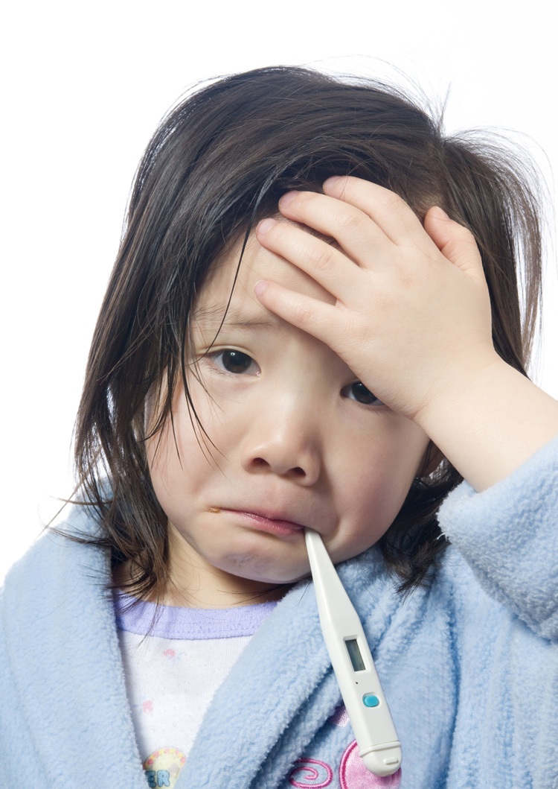  Current guidelines for acute bronchiolitis management  Wintertime brings many cold and flu viruses that cause upper and lower respiratory illnesses. Bronchiolitis, a lower respiratory tract disease process, is a major causative agent for office and emergency department visits. Treatment is aimed at supportive measures  Defining Bronchiolitis: Bronchiolitis is a clinical syndrome occurring in children less than 2 years of age that is characterized by upper respiratory symptoms (rhinorrhea) and lower respiratory (small airway) infection with inflammation which results in wheezing and/or crackles. Most often the causative agent is viral  Severity assessment is based on appearance and the potential for progression to respiratory failure:  - Severe increased work of breathing: persistently increased respiratory effort during repeated exams (tachypnea, nasal flaring, retractions, accessory muscle use)  - Hypoxemia (SpO2 <95%) accounting for altitude  - Apnea  - Acute respiratory failure  Indications for hospitalization:  - Toxic appearance, poor feeding, dehydration, lethargy  - Apnea/respiratory distress  - Hypoxemia that is persistent  - Lack of home care  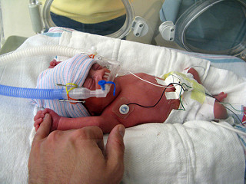  Treatment options and interventions:  - Suctioning and airway clearance are the mainstays of therapy.  - Supplemental oxygen and positive pressure via High Flow Nasal Cannula may be required to maintain SpO2 above 90-92% and decrease work of breathing  - Current recommendations do not include the use of bronchodilators, hypertonic saline, glucocorticosteroids, or leukotriene inhibitors (AAP).  - Children over the age of 1 with extensive family history of asthma may benefit from a trial of nebulized albuterol.  - Xrays are not routinely indicated in bronchiolitis  Anticipatory Guidance for Respiratory Illnesses  How long will my child’s cough last: 8-15 days  Tools for nasal clearing:  Bulb syringe with saline https://www.youtube.com/watch?v=uNl31A_b_bs  Nose Frida/Nasal Aspirator https://www.youtube.com/watch?v=UsLFKfGuioE  Saline spray  Humidifiers  Prevention:  Handwashing to minimize transmission.  Minimizing passive exposure to smoke  Avoiding contact with individuals showing signs of respiratory illness  Palivizumab immunization for high risk infants  Influenza vaccination yearly after 6 months of age  References:  www.aap.org  www.uptodate.org
    - PEC SIG
  4/1/2018
  UPCOMING EVENTS
  - May 2019 CHOP APP Conference
 | Spring is rapidly approaching and so is the first anniversary of our SIG. It has been a big year and we have accomplished a lot, but there is a lot more work to do. We would like to thank all of our current members for their continued support as well as welcome any future ones!  We would love to hear from you! Do you have ideas for a topic for the newsletter? An interesting case to share? A clinical practice issue? A legislative issue of importance to the group? Please feel free to post a discussion on our discussion board or email one of us.  Let’s make our second year even better than the first!  Nicole and Hilary
    - Contact Us
  Pediatric Emergency Care
  NAPNAP Special Interest Group
  5 Hanover Square
  Suite 1401
  New York, NY 10004
  www.napnap.org/pec
  pediatricemergency@napnap.org
  Chair: Nicole Koepke, CRNP CPNP-PC
  Co-Chair: Hilary Vaswani, CRNP, PC/AC-BC

